

Year 12 Chemistry
Trial Examination 2016
ANSWERS

Section 1 |  | Section 2 |  |  | Section 3 |  |  | Totals
No. Correct | Out of | Q | Mark | Out of | Q | Mark | Out of |  | Mark | Out of
 | 25 | 26 |  | 9 | 37 |  | 14 | Section 1 |  | 50
 |  | 27 |  | 6 | 38 |  | 12 | Section 2 |  | 70
 |  | 28 |  | 6 | 39 |  | 20 | Section 3 |  | 80
 |  | 29 |  | 8 | 40 |  | 18 | Total |  | 200
 |  | 30 |  | 10 | 41 |  | 16
 |  | 31 |  | 6 |  |  |  | Total |  | %
 |  | 32 |  | 5
 |  | 33 |  | 3
 |  | 34 |  | 4
 |  | 35 |  | 4
 |  | 36 |  | 9
 |  | Total |  | 70 | Total |  | 80

STRUCTURE OF THE PAPER
Section | Format | No. of  questions  set | No. of questions to be attempted | Recommend  time (minutes) | Marks Allocated | % of Exam
1 | Multiple Choice | 25 | ALL | 50 | 25 | 25%
2 | Short Answer | 11 | ALL | 60 | 70 | 35%
3 | Extended Response | 5 | ALL | 70 | 80 | 40%

Instructions to candidates
1. Answer the questions according to the following instructions.
Section One: Answer all questions on the separate Multiple-choice Answer Sheet provided. For each question shade the box to indicate your answer. Use only a blue or black pen to shade the boxes. If you make a mistake, place a cross through the square and shade a new answer. Do not erase or use correction fluid. Marks will not be deducted for incorrect answers. No marks will be given if more than one answer is completed for any one question.
Sections Two and Three: Write answers in the Question/ Answer Booklet.
2. When calculating numerical answers, show your working or reasoning clearly. Express numerical answers to three significant figures and include appropriate units where applicable.
3. You must be careful to confine your answers to the specific question asked and to follow instructions that are specific to a particular question.
4. Spare pages are included at the end of the booklet. They can be used for planning your responses and/ or as additional space if required to continue an answer.
- Planning: If you use the spare pages for planning, indicate this clearly at the top of the page.
- Continuing an answer: If you need to use the space to continue an answer, indicate in the original answer space where an answer is to be continued, i.e. give the page number. Fill in the number of the question(s) that you are continuing to answer at the top of the page.

Section One: Multiple Choice 25 marks (25% of paper)
This section contains 25 questions. Answer all questions on the Multiple–choice Answer Sheet provided. Use blue or black pen only. If you make a mistake, place a cross through that square. Marks will not be deducted for incorrect answers. No marks will be given if more than one answer is given for any question.
Suggested working time for this section is 50 minutes.
______________________________________________________________________________________
1. In the reaction below the potential energy of the products is greater than the potential energy of the reactants

N_{2(g)} + O_{2(g)}  2NO_{(g)}

If the temperature of the above system was increased at equilibrium, the mass of NO would:

A. increase and the K value would increase
B. increase and the K value would decrease
C. decrease and the K value would increase
D. decrease and the K value would decrease

2. When carbon dioxide (CO₂) dissolves in water, the following equilibria are established.

Reaction 1: CO₂(aq) + H₂O(l)  H₂CO₃(aq)
Reaction 2: H₂CO₃(aq) + H₂O(l)  H₃O⁺ (aq) + HCO₃⁻ (aq)
Reaction 3: HCO₃⁻ (aq) + H₂O(l)  H₃O⁺ (aq) + CO₃²⁻ (aq)

Ca²⁺ ions were added to the system and insoluble CaCO₃ formed. Which of the following statements are true?

- The concentration of H₂CO₃ would increase
- The concentration of CO₃²⁻ would increase
- The equilibrium position of Reaction 2 would shift to the right
- The equilibrium position of Reaction 3 would shift to the left

3. Methanol is synthesized using the following process.

CO₂(g) + 2H₂ (g)  CH₃OH (g)
In order to maximise the yield of methanol, a relatively low temperature (250°C) is used. It follows that the reaction is:
- Endothermic and the yield of methanol would be increased if a lower pressure was used.
- Endothermic and the yield of methanol would be increased if a higher pressure was used.
- Exothermic and the yield of methanol would be increased if a lower pressure was used.
- Exothermic and the yield of methanol would be increased if a higher pressure was used.

4. If the equilibrium solution described below was diluted by the addition of water, then:

Ag⁺(aq) + 2NH₃(aq)  Ag(NH₃)₂⁺ (aq)
- The reverse reaction rate would increase
- The equilibrium position would shift to the right
- The mass of Ag⁺ present would increase
- The concentration of Ag⁺ would increase

5. Which of the following best describes a condition that is necessary for the following to be at equilibrium?

CaCO₃(s)  CO₂(g) + CaO (s)

- The partial pressure of CO₂ in the reaction vessel must remain constant
- The ratio of [CO₂][CaO] / [CaCO₃) must be equal to 1
- The masses of CaCO₃ and CaO must be equal to each other
- The forward rate must be zero, so that the mass of CaCO₃ remains constant

6. 1.00 mol of N₂ and H₂ respectively were placed into a 1.00 L container and the reaction proceeded according to the following equation.

N₂(g) + 3H₂(g)  2NH₃(g)

Once equilibrium had been established, the concentration of N₂ was 0.8 molL⁻¹. Which of the following correctly describes the concentration of H₂ and NH₃ at equilibrium.

 | [H₂] | [NH₃]
A | 1.2 | 1.6
B | 0.4 | 0.4
C | 0.4 | 1.6
D | 0.8 | 0.4

7. Which statement about hydrogen sulfide (H₂S) and its ions is correct?

A. HS– is the conjugate base of S^{2–}.
B. H₂S is the conjugate acid of H₃S⁺.
C. S^{2–} is the conjugate base of HS–.
D. HS– is the conjugate acid of H₂S.

8. Which of the following solutions describes the buffer with the highest buffering capacity?

- Equal volumes of 0.5 molL⁻¹ Na₂HPO₄ and 0.5 molL⁻¹ K₃PO₄
- Equal volumes of 2.0 molL⁻¹ Na₃PO₄ and 2.0 molL⁻¹ K₃PO₄
- Equal volumes of 2.0 molL⁻¹ Na₃PO₄ and 1.0 molL⁻¹ KOH
- Equal volumes of 2.0 molL⁻¹ Na₂HPO₄ and 1.0 molL⁻¹ KOH

9. Two students standardised a hydrochloric acid solution by each pipetting 20.00 mL of it into a conical flask and titrating it against a standard sodium carbonate solution from a burette. The sodium carbonate had a concentration of 0.100 molL⁻¹. Using the same solutions, they obtained the following results for their average titre:

Student A: 21.72 mL
Student B: 22.47 mL

Which of the following statements is consistent with their results?

- The concentration of HC is approximately 0.100 molL⁻¹
- Student A’s pipette was slightly wet on the inside before being filled with HC
- Student A used phenolphthalein indicator (pH range: 8.2 - 10 ) and Student B used methyl orange indicator (pH range: 3.1 - 4.4)

- The pH at the equivalence point would have been greater than 7 for both students.

10. A series of reactions were carried out between acids and sodium salts. Each
reaction proceeded almost to completion. Equations for the reactions were:

HNO₂(aq) + OI⁻(aq)  HOI(aq) + NO₂⁻(aq)
HIO₃(aq) + CO₂⁻(aq)  IO₃⁻(aq) + HCO₂(aq)
HCO₂(aq)) + NO₂⁻(aq)  CO₂⁻(aq) + HNO₂(aq)
HCO₂(aq) + OI⁻(aq)  CO₂⁻(aq) + HOI(aq)

Rank the acids from strongest to weakest?

A. HIO₃(aq) HOI(aq) HIO₃(aq) HNO₂(aq)
B. HCO₂(aq) HIO₃(aq) HNO₂(aq) HOI(aq)
C. HIO₃(aq) HCO₂(aq) HNO₂(aq) HOI(aq)
D. HOI(aq) HNO₂(aq) HCO₂(aq) HIO₃(aq)

Questions 11 and 12 refer to the following diagram.

A 40.0 mL sample of an acid, HA, of unknown concentration is titrated against 0.100 molL⁻¹ NaOH and the resultant pH of the solution measured using a pH meter.

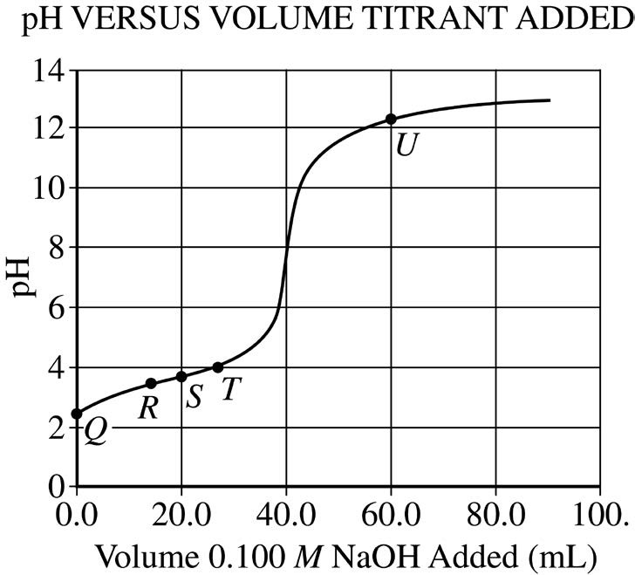

11. At point Q in the titration, which of the following species has the highest concentration?

- HA
- A⁻
- H₃O⁺
- OH⁻

12. At which point on the titration curve is [HA] = [A⁻ ]

- R
- S
- T
- U

13. The table below lists the pH of 0.001 molL⁻¹ solutions of four acids:

Acid solution | pH
I | 4.0
II | 3.5
III | 5.0
IV | 3.0

The acid that cannot be monoprotic and weak is:

A. I
B. II
C. III
D. IV

14. Which of the following are not redox reactions?

I. N₂O₄ → 2NO₂
II. N₂O₅ + H₂O → 2HNO₃
III. N₂O + 2H₂O → NH₄NO₃
IV N₂H₄ + H₂ → 2NH₃

A. I and II only
B. I, II and III only
C. I, III and IV only
D. III and IV only

15. In which of the following is oxygen in the highest oxidation state?

A. SO₃
B. H₂O₂
C. O₃
D. S₄O₆²⁻

16. How many moles of electrons are transferred when 1 mole of Cr²⁺ is converted to Cr₂O₇²⁻ ?

A. 4 moles of electrons are lost
B. 4 moles of electrons are gained
C. 8 moles of electrons are lost
D. 8 moles of electrons are gained

17. Which of the following would be able to react with 1.0 molL⁻¹ hydrochloric acid giving off hydrogen, but would be unable to displace Mn²⁺ from solution?

A. Ca
B. Cd
C. Cu
D. C₂

18. The Cu/Cu²⁺(aq) half-cell is connected up to another metal/metal ion half-cell using standard conditions. It is found that the voltage of the cell is greater than 1.00 V and the mass of copper metal decreases as the cell operates. Which of the following is a possible identity of the metal/metal ion half-cell?

A. Zn/Zn²⁺(aq)
B. Ag/Ag⁺(aq)
C. Au/Au³⁺(aq)
D. None of the above

19. Which of the following is false about corrosion?

A. the cathode reaction involves the reduction of oxygen
B. oxidation occurs where the concentration of oxygen is low
C. iron metal is the reductant
D. 1 mole of oxygen reacts with 1 mole of iron

20. When an organic compound, A, is warmed in an aqueous solution containing hydrochloric acid, it gives two different compounds, B and C. If the mixture of B and C is then treated with an excess of a solution of acidified potassium dichromate, a single organic compound, B results. Compound A is probably:

A. CH₃CH₂COOCH₂CH₃
B. CH₃COOCH₂COOH
C. CH₃COOH
D. CH₃COOCH₂CH₃

21. How many primary alcohols have the molecular formula C₄H₉OH?

A. 1
B. 2
C. 3
D. 4

22. Consider the following substances:

Substance (I)
Substance (II)
Substance (III)
Substance (IV)

Which of these structures would be unsuitable for use in a cleaning product?

A. Substance (I) only
B. Substance (II) only
C. Substance (III) and substance (IV)
D. Substance (II) and substance (IV)

23. In how many positions can one chlorine atom be substituted in the straight chain alkane C₆H₁₄, to give rise to different compounds?

A. 2
B. 3
C. 4
D. 6

24. Which one of the following DOES NOT represent a pair of isomers?

A. Ethyl butanoate and butyl ethanoate.
B. 2-methylpropan-2-ol and butan-2-ol.
C. Cis-1,2-difluorobut-1-ene and trans-1, 2-difluorobu-1-tene.
D. 2-methyl pent-1-ene and cyclohexene

25. Enzymes, which are composed mostly of protein, catalyse many chemical reactions. The structure of a portion of an enzyme with some of its constituent atoms shown, is represented below.
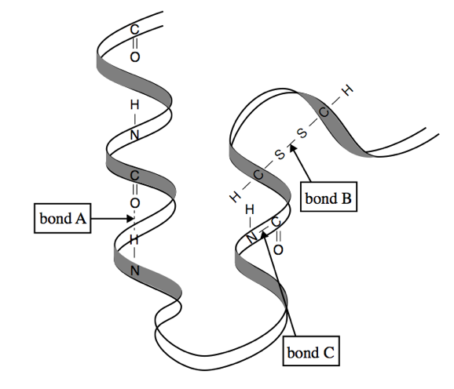

Which level of the protein structure is is each of the labelled chemical bonds involved in?

 | Bond A | Bond B | Bond C
A. | secondary | primary | tertiary
B. | secondary | tertiary | primary
C. | tertiary | primary | secondary
D. | primary | secondary | tertiary

END OF SECTION 1
Section Two: Short Answer 70 marks (35% of paper)

This section has eleven questions. Answer all questions. Write your answers in the spaces provided.
When calculating numerical answers, show your working or reasoning clearly. Express numerical answers to three significant figures and include appropriate units where applicable.
Spare pages are included at the end of this booklet. They can be used for planning your responses and/or additional space if required to continue an answer.
- Planning: If you use the spare pages for planning, indicate this clearly at the top of the page
- Continuing an answer. If you need to use the space to continue an answer, indicate in the original answer space where the answer is continued, i.e. give the page number. Fill in the number of the question(s) that you are continuing to answer at the top of the page.

Suggested time for working for this section is 60 minutes.
______________________________________________________________________________________

Question 26 (9 marks)

Carbon disulphide can be manufactured by the endothermic reaction of sulfur trioxide and carbon dioxide according to the following equation:

2SO₃(g) + CO₂(g)  CS₂(g) + 4O₂(g)

(a) This reaction was allowed to come to equilibrium at 100°C and at a pressure of 400 kPa. The changes in the following table were imposed, and equilibrium re-established. Complete the table, describing the effects of each imposed change. Use the terms increase, decrease or no change.

Imposed Change | Mass of CS₂ | Forward reaction rate
(i) Removing SO₃ from the reaction mixture | decrease | decrease
(ii) Increase the volume at constant temperature | increase | decrease
(iii) Raising the temperature to 200°C at constant pressure | increase | increase
(6 marks)

(b) Use collision theory to explain your reasoning for part (i) above.

The number of collisions between reactant particles decreases ✓
The rate of the forward reaction decreases ✓
The mass of CS2 decreases as the equilibrium shifts toward the reactants ✓

(3 marks)

Question 27 (6 marks)
The graph below represents the concentration of reactants and products at equilibrium for the following reaction:

CO₂(g) + CF₄(g)  2COF₂(g) ΔH < 0

(a) Sketch the appropriate changes in concentrations of CF₄ and COF₂ if:

(i) At time t₁ the temperature is increased.

(ii) At time t₂ equilibrium is restored

(iii) At time t₃ more CO₂ is injected into the vessel

(iv) At time t₄ equilibrium is restored (4 marks)

increase T at t₁ ✓
add CO₂ at t₃ ✓
restore equilibrium at t₂ and t₄ ✓
2:1 ratio at t₁ and t₃ ✓

Concentration
CF₄ ______________
__
COF₂ ______________
__
__

0 t₁ t₂ t₃ t₄ Time (minutes)

(b) What happens to the value of the equilibrium constant for the reaction between the following times. State whether it will increase, decrease or remain the same.

(i) Between t₁ and t₂: decrease ✓ (1 mark)

(ii) Between t₃ and t₄: remain the same ✓ (1 mark)

Question 28 (6 marks)

A volumetric analysis was carried by out by two students in order to determine the percentage purity of a solid sample of barium hydroxide. The following procedure was used:

- 2.45 g mass of the sample was dissolved in water and made up to 250 mL in a volumetric flask.
- This solution was used to fill the burette.
- 25 mL portions of 0.100 molL⁻¹ hydrochloric acid were pipetted into conical flasks.
- A few drops of phenolphthalein indicator (end point range pH 8-10) were added to the conical flasks.
- These conical flasks were titrated with the barium hydroxide solution and an average titre of 13.6 mL was obtained.
- These results were used to calculate the percentage purity of the barium hydroxide.

Student 1 carried out the experimental work. Student 2 used the results to calculate the percentage purity of the barium hydroxide.

Unfortunately Student 1 did not bother to read the procedure carefully and he made mistakes. Student 2 took the experimental results in good faith assuming the procedure had been followed exactly and calculated the percentage purity of the barium hydroxide.

Predict the effect on both the titre volume and the calculated percentage purity of the barium hydroxide if Student 1 made the the following mistakes when carrying out the procedure. You may assume that no errors are made with the calculation. Use the following terms; increase, decrease, no change in your answers.

Mistake made by Student 1 | Effect on the titre volume obtained | Effect on the calculated percentage purity of the barium hydroxide
The burette was rinsed with water before it was filled with the barium hydroxide solution. | increase | n(Ba(OH)₂ in titre same  x 250/ v(titre); n(Ba(OH)₂ less  m(Ba(OH)2 and % purity less  decrease
10mL samples of 0.1 molL⁻¹ hydrochloric acid were pipetted into conical flasks. | decrease | n(Ba(OH)₂ in titre less  x 250/ v(titre); n(Ba(OH)₂ more  m(Ba(OH)₂ and % purity more  increase
25.0 mL aliquots of  0.200molL⁻¹ hydrochloric acid were used. | increase | n(Ba(OH)₂ in titre more  x 250/ v(titre); n(Ba(OH)₂ less  m(Ba(OH)₂ and % purity less  decrease

✓ each box

Question 29 (8 marks)

Hydrogen cyanide (HCN) is a highly toxic gas. It dissolves in water and forms an equilibrium between its gaseous and aqueous molecules.

HCN (g)  HCN (aq)

HCN then reacts with water to form a weak acid.

(a) Write an equation for the reaction of hydrogen cyanide with water and identify the conjugate acid- base pairs.

Equation: HCN + H₂O  H₃O⁺ + CN⁻ ✓

Pair 1 ✓  Acid HCN Base CN⁻ | Pair 2 ✓  Acid H₃O⁺ Base H₂O
(3 marks)

(b) Hydrogen cyanide is used in the gold industry and is stored in large open ponds.
As a safety precaution sodium hydroxide is added to the ponds to keep them alkaline (pH > 7). Explain why.

NaOH reacts with H₃O⁺ ✓
Equilibrium favours the formation of products ✓
[HCN] in solution decreases and reduces evaporation of HCN (g) ✓
(3 marks)

(c) A 0.1 molL⁻¹ solution of HCN has a pH = 5.2 . Calculate the % ionisation of the HCN.

% ionisation = [H₃O⁺]/[HCN] x 100 ✓
= 10^{-5.2}/10⁻¹ x 100
= 6.31 x 10⁻³ % ✓ (2 marks)

Question 30 (10 marks)

A student set up the following apparatus.

In the left-hand beaker, a chromium electrode is placed into a solution containing 50.0 mL of 1.00 molL⁻¹ chromium (III) nitrate.

In the right-hand beaker, a platinum electrode is placed into 50.0mL of a solution containing both
1.00 molL⁻¹ iron (II) nitrate and 1.00 molL⁻¹ iron (III) nitrate.
Electrons à
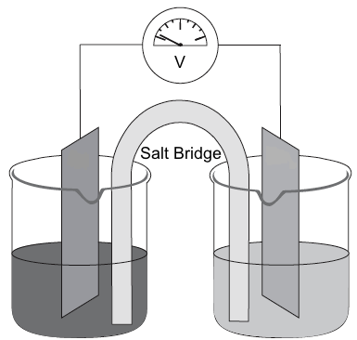

Anode
✓✓✓

à +ve ions

(a) Add a label to the diagram to show the anode
(1 mark)

(b) By adding an arrow to the diagram, show the direction of electron flow in the external circuit.
(1 mark)

(c) Add another arrow to show the direction of flow of positive ions in the salt bridge.
(1 mark)

(d) Write an equation for the overall reaction in the cell and determine the value shown on the voltmeter.

Cr + 3 Fe³⁺ → Cr³⁺ + 3 Fe²⁺ ✓
E⁰_{Cell} = 0.44 + 0.77 = 1.51V ✓
(2 marks)

(e) After operation, it was found that the mass of the chromium electrode changed by 0.16 g. Calculate the final concentration of the iron (II) ions in the right hand beaker.

n(Cr) = 0.16/52 = 3.077 x 10⁻³ mol ✓
n(Fe²⁺) formed = 3.077 x 10⁻³ x 3 = 9.23 x 10⁻³ mol ✓
total n(Fe²⁺) = 9.23 x 10⁻³ + (1 x 0.05) = 0.05923 mol ✓
c(Fe2+) = 0.05923/0.05 = 1.1846 molL⁻¹ ✓
(4 marks)

(f) What will happen to the mass of the electrode in the right hand cell? Circle the correct answer below.

Decreases Stays the same Increases ✓
(1 mark)

Question 31 (6 marks)

Two colourless solutions, sulfuric acid and potassium iodide, can react with each other to form a yellow solid and a brown solution. Use this information to construct oxidation and reduction half-equations and a full equation for the reaction taking place.

Oxidation half-equation | 2I⁻ → I₂ + 2e⁻ ✓✓
Reduction half-equation | SO₄²⁻ + 8H⁺ + 6e⁻ → S + 4H₂O ✓✓
Full equation | 6I⁻ + SO₄²⁻ + 8H⁺ → 3I₂ + S + 4 H₂O ✓✓  or H₂SO₄ + 6H⁺  or HSO₄⁻ + 7H⁺

-1 for oxidation / reduction equations the wrong way around;
ecf if the reduction half equation was incorrect but the full equation was correct

Question 32 (5 marks)

(a) For each of the following, draw the structural formula of the main organic product(s).

(i) ethyl ethanoate is boiled with sodium hydroxide

(ii) Excess acidified potassium permanganate is added to 2-methylbutan-1-ol.

(iii) But-2-ene forms an addition polymer (show 2 repeating units).

(3 marks)

(b) The polymer Nylon-6,6, is a polyamide. Here is a section of Nylon-6,6:

Provide the monomer(s) necessary to produce Nylon-6,6 in the spaces below:
(2 marks)

Question 33 (3 marks)

Propan-2-ol has a higher boiling point (82^{O}C) than propanone (56^{O}C). Explain.

Propan-2-ol: H- bonding and dispersion forces ✓
Propanone: dipole - dipole and dispersion forces ✓
Strength of H- bonding > dipole - dipole; dispersion forces equivalent. ✓

Question 34 (4 marks)

Give a chemical test and an observation to show how you would distinguish between the following organic compounds.

(a) hexan-1-ol and hexane

Test Add a piece of sodium to each/ add acidified potassium permanganate or dichromate ✓

Observation the sodium reacts with the hexan-1-ol to form bubbles. There is no reaction in the ✓ hexane / colour change purple to pale pink or, orange to deep green (2 marks)

(b) propanone and propanoic acid

Test: Add a small quantity of sodium carbonate to each ✓

Observation the sodium carbonate reacts with the propanoic acid to form bubbles. There is no ✓ reaction in the propanone
(2 marks)

Alternatives
Adding a carboxylic acid/ H₂SO₄ to (a) and getting a fruity smell with hexan-1-ol.
Adding an alcohol/ H₂SO₄ to (b) and getting a fruity smell with propanoic acid.
Since H₂SO₄ is a catalyst the above was accepted without it
Adding a reactive metal to (b) with propanoic acid producing a colourless gas

Question 35 (4 marks)
The component of sunscreen that absorbs UV light and prevents sunburn is zinc oxide (ZnO). There are concerns that zinc in the form of Zn²⁺ can pass through the skin and have negative health effects.
In a research project scientists attempted to measure the quantity of Zn²⁺ in sunscreen that passes across the skin into the body using Atomic Absorption Spectroscopy (AAS).
The following experiment was set up.
1. Zinc oxide (ZnO) was applied to the outer surface of a skin-like material.

2. The level of Zn²⁺ present on the inner surface was determined 2 hours later, using AAS to measure the amount of light that is absorbed by the metal ions.

Four standard solutions of known Zn²⁺ concentrations and one blank (pure water) were used in the experiment and the absorbance (proportion of light absorbed) was measured. The following results were obtained and a calibration graph was constructed.

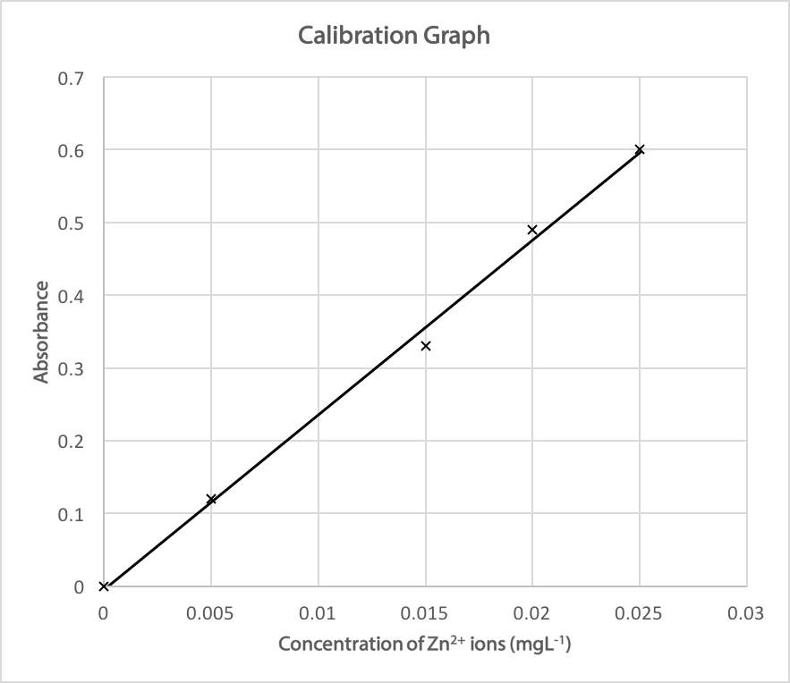

Use the information given and the data on the graph to answer the following:

(a) State the evidence in the graph that indicates the presence of random errors.

Data falls either side of the line of best fit. ✓ (1 mark)

(b) State one thing that the researchers could have done to improve the reliability of the absorbance readings.

Repeat the 0.015 mgL⁻¹ absorbance reading; take an absorbance reading with a 0.01 mgL⁻¹ concentration; repeat trials and take averages of the absorbance ✓ (1 mark)

(c) State one thing that the researchers could have done to improve the validity of the experimnental procedure.

use real skin in preference to the "skin like " material or use sunscreen instead of pure ZnO ✓ (1 mark)

(d) After the 2 hours the inner surface of the skin-like material gave an absorbance reading
of 0.52. Use the graph to determine the concentration of Zn²⁺ for the sample.

Concentration = 0.0215 - 0.022 mgL⁻¹ ✓ (1 mark)

Question 36 (9 marks)

Electrolysis is a process where chemical change is brought about by passing an electric current through an electrolyte. One such example is the electrorefining of copper, using copper electrodes and copper(II)sulfate solution. Use this information to complete the following:

(a) Draw a labelled diagram to show this electrolytic cell, showing the power supply and electrodes. ✓

On the diagram indicate: (i) flow of electrons; ✓
(ii) flow of relevant ions; ✓
(iii) anode and cathode. ✓

Electrons →
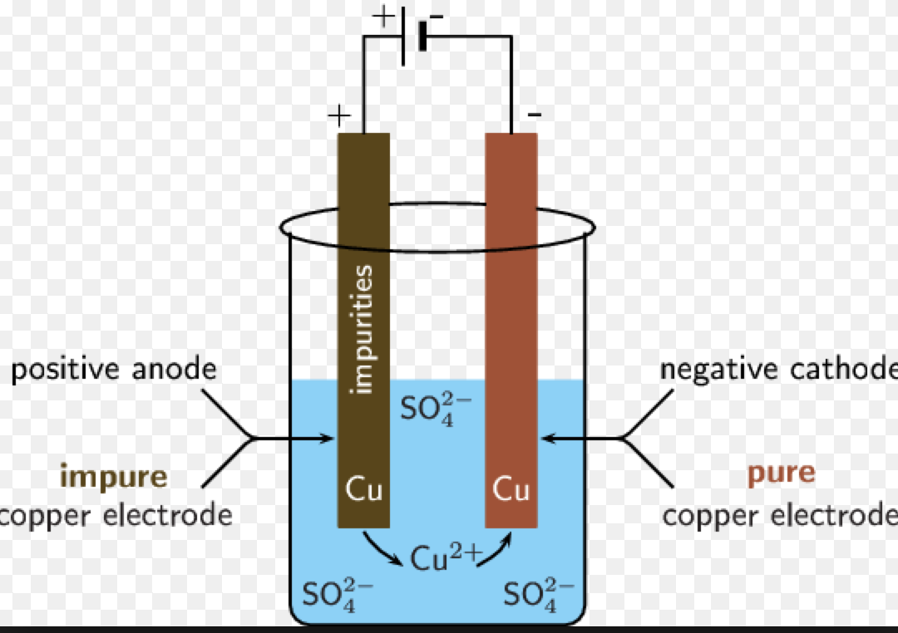
(4 marks)

(b) Write a half equation to show the reaction occurring at the positive electrode.

Cu → Cu²⁺ + 2e⁻
(1 mark)
(c) The positive electrode contains gold and zinc impurities. Using the table of Standard Reduction Potentials explain what happens to these impurities as the cell operates.

The zinc dissolves ✓
The gold drops to the bottom of the container forming anodic mud ✓

Zn → Zn²⁺ +2e⁻ E⁰ = 0.76 V
Cu → Cu²⁺ + 2e⁻ E⁰ = 0.34V
Au → Au³⁺ + 3e⁻ E⁰= -1.50 V
The zinc in contact with the copper is more readily oxidised and dissolves into solution as Zn²⁺ ✓
The copper in contact with the gold is more readily oxidised and dissolves into solution as Cu²⁺ ✓
(4 marks)

END OF SECTION TWO
Section Three: Extended answer 80 marks (40% of paper)

This section contains five questions. You must answer all questions. Write your answers in the spaces provided.
Where questions require an explanation and/or description, marks are awarded for the relevant chemical content and also for coherence and clarity of expression. Lists or dot points are unlikely to gain full marks.
Final answers to calculations should be expressed to three significant figures.
Spare pages are included at the end of this booklet. They can be used for planning your responses and/or as additional space if required to continue an answer.
- Planning: If you use the spare pages for planning, indicate this clearly at the top of the page.
- Continuing an answer: If you need to use the space to continue an answer, indicate in the original answer space where the answer is continued, i.e. give the page number. Fill in the number of the question(s) that you are continuing to answer at the top of the page.
Suggested working time for this section is 70 minutes.
______________________________________________________________________________________

Question 37 (14 marks)

Within the human body, proteins are responsible for nearly every task of cellular life. Their function is dependent entirely upon their structure. Each protein has a pH range in which it functions optimally. Outside this pH range, the protein’s structure and hence its function can be lost.

The pH within the human body is tightly controlled by a series of buffer systems. One of the major buffers present is the phosphate buffering system, as shown below:

Reaction1: H₃PO₄ (aq) + H₂O  H₃O⁺ (aq) + H₂PO₄⁻ (aq)

Reaction 2: H₂PO₄⁻ (aq) + H₂O  H₃O⁺ (aq) + HPO₄²⁻ (aq)

Reaction 3: HPO₄²⁻ (aq) + H₂O  H₃O⁺ (aq) + PO₄³⁻ (aq)

(a) Write the expression for the equilibrium constant for Reaction 1

K = [H₃O⁺][H₂PO₄⁻]/[H₃PO₄] ✓

(1 mark)

(b) The value for the equilibrium constant (Ka) for Reaction 2 is 6.23 x 10⁻⁸ at 25°C. This value changes to 7.82 x 10⁻⁸ at 40°C. Is it an endothermic or exothermic reaction? Circle the correct alternative below and explain your answer.

Endothermic Exothermic? ✓ (1 mark)

Explanation:

As T increases, K increases. ✓
This means [products] increases. ✓
Increase in temperature favours the endothermic process, therefore the forward reaction is endothermic. ✓

(3 marks)

(c) Within the human body, H₂PO₄⁻ and HPO₄²⁻ are present at far greater concentrations than are H₃PO₄ and PO₄³⁻. Which of the three reactions provides the greatest buffer capacity? Explain.

Reaction 2 ✓
Buffer capacity is the greatest when the acid and its conjugate base are in equal and high concentration
Reaction 2 satisfies these conditions to a greater extent than Reactions 1 and 3. ✓
(2 marks)

(d) Explain how Reaction 2 acts as a buffer if the [OH⁻] increases. Use appropriate equations in your answer.

H₂PO₄⁻ + H₂O  H₃O⁺ + HPO₄²⁻

When a base is added to the buffer, the hydroxide ions react with the dihydrogenphosphate ions according to the following reaction.
OH⁻+ H₂PO₄⁻  HPO₄²⁻ + H₂O (accept H₃O⁺ + OH⁻ → 2H₂O) ✓

The hydroxide ions are consumed. ✓
Change in pH is minimised ✓

(3 marks)

(e) Phosphate ions are used within the body to phosphorylate a number of other molecules. When this occurs, the concentration of phosphate ions (PO₄³⁻) decreases.

How does the pH change when the concentration of phosphate ions decreases? Circle the correct answer.

Increases decreases stays the same ✓

(1 mark)

(f) Within a protein chain, the two amino acids that are most susceptible to subtle changes in pH are histidine and cysteine. As shown below, they can gain orlose protons between pH 6 and 8 respectively. Note that only the side chains are shown.

Histidine:
pH < 6 | pH > 6
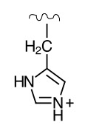 | 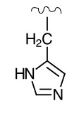

Cysteine:
pH < 8 | pH > 8
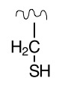 | 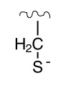

(i) What is the major intermolecular force that would exist between these two amino acids at the following pH values?

Major intermolecular force at pH 7: dipole - dipole ✓

Major intermolecular force at pH 5: ion - dipole ✓

(2 marks)

(ii) At which pH would you expect the intermolecular forces to be the strongest: pH 5 or pH 7?

pH = 5 ✓
(1 mark)
Question 38 (12 marks)
The solubility of highly soluble, thermally unstable salts such as ammonium chloride, NH₄C, may be determined by back titration.
In one experiment, 10.0 mL of a saturated solution of ammonium chloride at 20°C, was diluted with distilled water to 500.0 mL in a volumetric flask.
A 20.0 mL aliquot of this solution was added to 20.0 mL of 0.200 molL⁻¹ NaOH solution. The solution was heated to drive off the ammonia formed by this reaction.
When the flask had cooled, the excess hydroxide ions were neutralised by 14.7 mL of 0.125 molL⁻¹ HC solution.

(a) Determine the amount, in moles, of ammonium chloride in the 20.0 mL aliquot.

n(H⁺) = 0.125 x 0.0147 = 0.001838 mol ✓
n(OH⁻) = n(H⁺) = 0.001838 mol in x.s ✓
n(OH⁻) in the 20 mL = 0.2 x 0.02 = 0.004 mol ✓
n(NH₄⁺) in the 20mL aliquot = 0.004 - 0.001838 = 0.002162 mol ✓
n(NH₄Cl) = 0.002162 mol = 2.16 x 10⁻³ mol
(4 marks)

(b) Calculate the amount, in moles, of ammonium chloride in 10.0 mL of the saturated solution.

n(NH₄⁺) = 0.002162 x 500/20 = 0.05405 = 5.41 x 10⁻² mol ✓ (1 mark)

(c) Calculate the solubility, in gL⁻¹ of ammonium chloride in water at 20°C.

m(NH₄Cl) in 10 mL = 0.05405 x 53.492 = 2.891 g ✓
solubility = [NH₄Cl] = 2.891/0.01 = 289.2 gL⁻¹ ✓
(2 marks)

(e) In this back titration, the end point occurred at a pH of 7. If a one step titration had been done where the ammonium chloride had been directly titrated with NaOH, the end point would have occurred at a pH >7. Explain this observation, using relevant equations where necessary.

In the back titration:
HCl + NaOH → NaCl + H2O
Na+ and Cl- cannot accept or donate a proton. NaCl is a neutral salt.
pH at equivalence = 7 ✓✓

In a one step titration
NH4Cl + NaOH → NaCl + NH3 + H2O
NH3 + H2O → NH4+ + OH-
solution has a pH > 7 at equivalence ✓✓✓

(5 marks)

Question 39 (20 marks)

Dipeptides are molecules are formed by the condensation reaction to join two amino acids. In order to establish its structure, a dipeptide consisting of carbon, hydrogen, oxygen and nitrogen was subjected to the following analysis.

Firstly, 1.82 g of the dipeptide was completely burnt in excess oxygen producing 2.73 g of carbon dioxide and 1.12 g of water.

Secondly, 3.68 g of the dipeptide was treated to convert all the nitrogen into nitric acid. The nitric acid was all dissolved in water and then made up to 100.0 mL in a volumetric flask. A 25.0 mL sample of this nitric acid solution was titrated and found to require 20.76 mL of 0.503 molL⁻¹ sodium hydroxide solution for neutralisation.

- Calculate the empirical formula of the dipeptide.

CO₂
% C = 2.73 x 12.01 x 100
44.01x1.82 = 40.934% ✓✓

H₂O
% H = 1.12 x 2 x 1.008 x 100
18.016 x 1.82 = 6.886% ✓✓

n(NaOH) = 0.503 x 0.02076 = 0.01044 mol ✓

n(HNO₃) in 25 mL = 0.01044 mol ✓

n(HNO₃) in 100 mL = 0.01044 X100/25 = 0.04177 mol ✓

n(N) = 0.04177 mol ✓

% (N) = 0.04177 x 14.01 x 100/3.68 = 15.9018% ✓

%(O) = 100 - %(C) - %(H) - %(N) = 36.2782% ✓

C : H : N : O
IN 100g 40.934 : 6.886 : 15.9018: 36.2782

n 3.408 : 6.831 : 1.135 : 2.267

/1.135 3.00 : 6.02 : 1 : 2.00

ratio 3 : 6 : 1 : 2 ✓✓

EF = C₃H₆NO₂ ✓

(13 marks)

In a final experiment, 0.362 g of the dipeptide was vapourised at 125⁰C and was found to occupy a volume of 113 mL at 60 kPa.

- Calculate the molecular formula of the dipeptide.

M(EF) = 3 x 12.01 + 6 x 1.008 + 1 x 14.01 + 2 x 16 = 88.088 gmol⁻¹

M = mRT/PV

M = 0.362 x 8.314 398.15
60 x 0.113 = 176.74 gmol⁻¹ ✓✓

M(MF)/M(EF) = 2 ✓

MF = C₆H₁₂N₂O₄

(3 marks)

- Given that the two amino acids contain equal numbers of carbon atoms, determine the identity of the two amino acids in the dipeptide.

+ H₂O to MF
identify Serine and Alanine ✓✓
(2 marks)

- Draw a possible structural formula of the dipeptide

Ala - Ser

OR
Ser - Ala

(2 marks)

Question 40 (18 marks)

Fuel cells use a continuous supply of chemicals to produce an electric current. The Direct Ethanol Fuel Cell (DEFC) is one such cell. As the cell operates, ethanol is converted into carbon dioxide at the anode, and oxygen converted into water at the cathode.

(a) Use the above information to construct the two half-equations and the full equation for the overall cell reaction

oxidation half equation | CH₃CH₂OH + 3H₂O → 2CO₂ + 12H⁺ + 12e⁻ ✓✓
reduction half equation | O₂ + 4H⁺ + 4e⁻ → 2H₂O x 3 ✓✓
overall equation | CH₃CH₂OH + 3O₂ → 2CO₂ + 3H₂O ✓✓

(6 marks)

Ethanol can be obtained by two methods; the fermentation of glucose and the hydration of ethene.

(b) Write an equation for the hydration of ethene; the equation for fermentation has been given to you.

Fermentation | C₆H₁₂O₆ → 2C₂H₅OH + 2CO₂
hydration of ethene | H₂C = CH₂ + H₂O → CH₃CH₂OH ✓
(1 mark)

In a particular process, 500 kg of a sugar mixture that contained 31% glucose was fermented for two weeks. The fermentation process was 27% efficient. The ethanol was then used in a DEFC that produced 320 kJ of energy per mole of ethanol used.

(c) Calculate the total amount of energy given off by the DEFC.

M(glucose) =72.06 + 12.096 + 96 = 180.156

n(glucose) = 0.31 x 5 x 10⁵
180.156 = 860.365 mol ✓✓

n(ethanol) = 2 x 860.365 x 0.27 = 464.60 mol ✓✓

E = n x 320 = 1.48 x 10⁶ kJ ✓
(5 marks)

(d) One reaction of alcohols is that they react with Group 1 metals. In an experiment, 0.452 g of an unknown Group 1 metal, X, was added to an excess of ethanol. The metal dissolved and a colourless gas was produced. The volume of gas that was given off was 62.6 mL measured at 26⁰C and 105 kPa.

- Write an equation for the reaction that is occurring between ethanol and X

2CH₃CH₂OH + 2X → 2CH₃CH₂O⁻ X⁺ + H₂ ✓✓
(2 marks)
(ii) Determine the identity of X

n(H2) = PV/RT = 105 x 0.0626 / 8.314 x 299.15 = 0.0026428 mol ✓

n(X) = 2 x n(H2) = 0.0052856 mol ✓

M(X) = m/n = 0.452/0.0052856 = 85.4 gmol⁻¹ ✓

X = Rb ✓
(4 marks)

Question 41 (16 marks)
The Solvay process is the process for the production of sodium carbonate (Na₂CO₃). Two important raw materials in this process are sodium chloride (NaC), which is obtained from seawater and calcium carbonate (CaCO₃) which is obtained from limestone.

In Step 1, ammonia and carbon dioxide are bubbled through water and solid sodium chloride is added.

NaC + CO₂ + NH₃ + H₂O → NaHCO₃ + NH₄C 92% efficient

In Step 2 sodium carbonate is produced and the carbon dioxide is recycled to Step 1

2 NaHCO₃ → Na₂CO₃ + H₂O + CO₂ 99% efficient

In Steps 3 and 4 the reagents for Step 1 in the process (CO₂ and NH₃) are generated.

In Step 3 calcium carbonate is heated in a process called calcination that provides reactants for Steps I and 4

CaCO₃ → CO₂ + CaO 100% efficient

In Step 4 ammonia is regenerated for use in Step 1

2NH₄C + CaO → 2NH₃ + CaC₂ + H₂O 89% efficient

(a) 1.0 kilolitre (kL) of a gas mixture containing equal volumes of NH₃ gas and CO₂ at 30^{O}C and
105 kPa are mixed and bubbled through water in Step 1.

(i) What mass of NaC (M= 58.44 gmol⁻¹) is required for complete reaction?

n(CO₂) = n(NH₃) Avogadro's hypothesis ✓

n(gas) = PV/RT = 105 x 1000/8.31 x 303 = 41.66 mol ✓

n(NaCl) required = 41.66/2 = 20.83 mol ✓

m(NaCl) = 20.83 x 58.44 = 1217.3 g = 1.22 kg ✓
(4 marks)

(ii) What mass of Na₂CO₃ (M = 105.99 gmol⁻¹) would be produced in Step 2 from this quantity of the gas mixture?

n(Na₂CO₃) = 0.5 x n(NaCl) x 0.92 x 0.99
= 0.5 x 20.83 x 0.92 x 0.99 = 9.486 mol ✓✓
m(Na₂CO₃) = 9.486 x 105.99 = 1005.42 g = 1.01kg ✓
(3 marks)

(iii) The CO₂ needed in Step 1 comes from Step 2 and Step 3. What mass of CaCO₃
(M = 100.09 gmol⁻¹) needs to be decomposed in Step 3 to provide the extra CO₂ required for a second kL of the gas mixture to be reacted?

n(CO₂) required in Step 1 = n(NaCl) = 20.83 mol ✓
n(CO₂) produced and recycled from Step 2 = n(Na₂CO₃) = 9.486 mol ✓

n(CO₂) required from Step 3 = 20.83 - 9.486 = 11.344 mol ✓
n(CaCO₃) required = n(CO₂) = 11.344 mol ✓
m(CaCO₃) = 11.344 x 100.09 = 1135.42 g = 1.14kg ✓

(5 marks)

See over for Q. 41(b)

(b) The reactions in Steps 3 and 4 are used to produce the NH₃ required for Step 1. What mass of CaCO₃ would need to be reacted in Step 3 to produce 1.0 kg of NH₃ in Step 4?

n(NH₃) = 1000/17.034 = 58.71 mol ✓
n(CaO) required = 0.5 x 58.71/0.89 = 33.0 mol ✓
n(CaCO₃) required = 33.0 mol ✓
m(CaCO₃) required = 33.0 x 100.09 = 6602.4 g = 3.30 kg ✓
(4 marks)

END OF EXAMINATION

